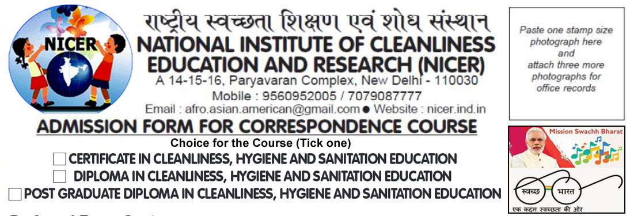
Preferred Exam Centre : ........................................................................................................
Name (in capital letters) : .............................................................................................................
Name of Father : .............................................................................................................
Name of Mother : .............................................................................................................
Date of Birth : ............................................Nationality ................................................
Address for Correspondence: ......................................................................................................
........................................................................................................................................................
........................................................................................................................................................
Tel ................................Mobile...................................Email...........................................................
Educational Qualification (attach copies of marks sheets and certificates)
Qualification | Year of Passing | Board / University / Institution | % of Marks

Permanent Address :...............................................................................................................
........................................................................................................................................................
Tel ................................Mobile...................................Email...........................................................
Details of Payment..........................................................................................................................
UNDERTAKING
I hereby declare that I am very keen to join this course in order to make the country cleaner and that the information mentioned above are true to the best of my knowledge and belief.

Date Place Applicant’s Signature

